# BUG REPORT

*Newly found Bugs will be updated*

## BUG 1

Title: Error handling to be done in the edit post page by flag

Attachment:

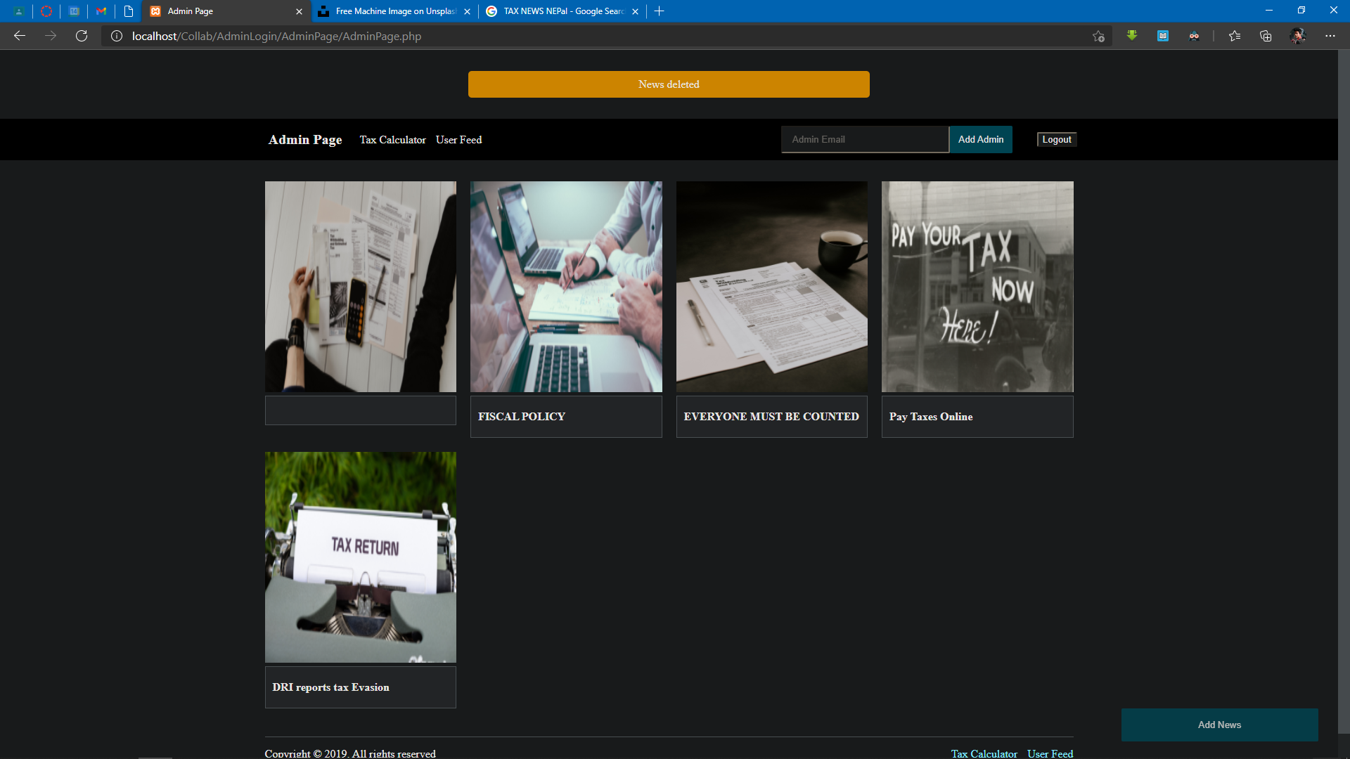

Steps to reproduce:

1. Go to Admin Page
2. Hover over a post
3. Edit the post
4. Leave the title empty
5. Click on update

Environment: Microsoft Edge Version 90.0.818.56

## BUG 2

Title: Error handling to be done in the create post page by flag

Attachment:

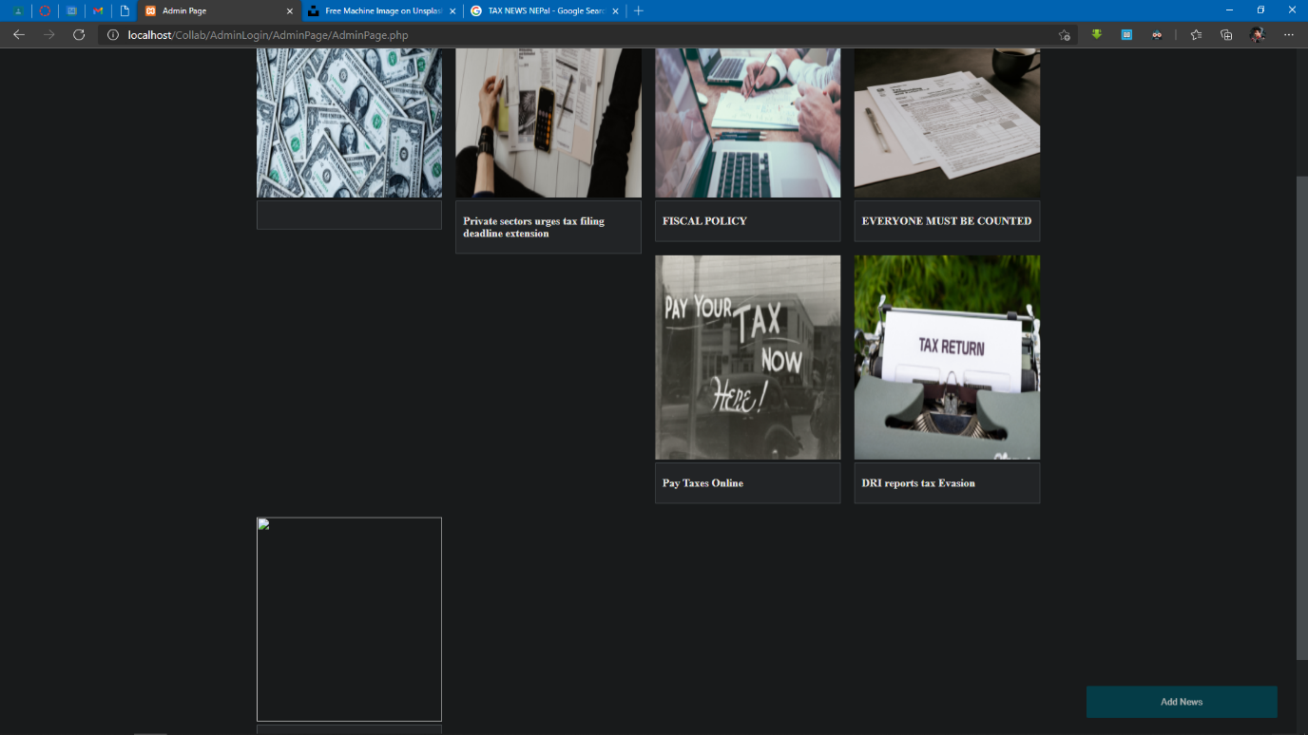

Steps to reproduce:

1. Go to Admin Page
2. Create a new post
3. Only input the text fields
4. Create the post
5. The post gets created

Environment: Microsoft Edge Version 90.0.818.56

## BUG 3

Title: Add a confirmation box while deleting

Attachment:

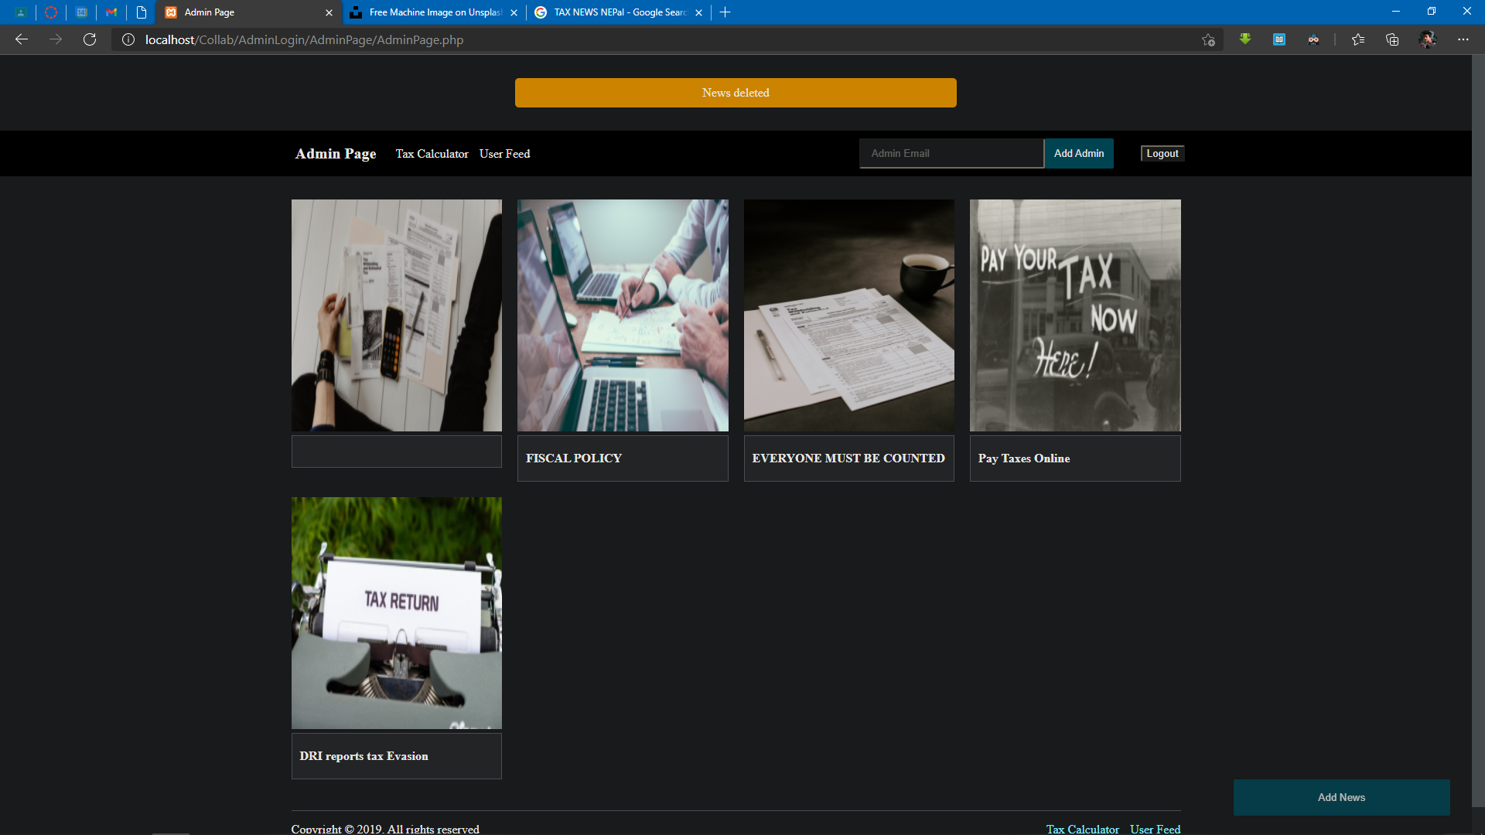

Steps to reproduce:

1. Hover over a post
2. Click on Delete

Environment: Microsoft Edge Version 90.0.818.56